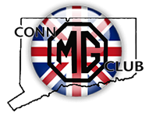
The CT MG Regalia Order Form

Name ___________________________________________________

Email ___________________________________________________

Phone ___________________________________

Quantity | Item | Size

Please use the above form for ordering items. You can save and upload this form to Kathy or Paul or by emailing them with your order as long as you have all the above information. Thank you for supporting the CT MG Club!

Kathy Dabrowski kstdabrowski@yahoo.com
Paul Angelico pangelico825@gmail.com

